DefectiveMinds.com Expansion Site

Contents
- The Website
- The Game
- The Animation

1. The Website

The website, which is an expansion to www.defectiveminds.com, will consist of a main page that will have the news and a login screen. It will also contain links to the forums on the main site, as well as integrate with the main site login. 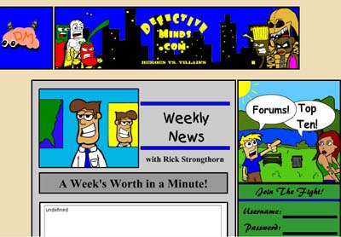

The expansion site will consist of flash objects. There will be a links are on the bottom, and each menu will be animated. The anchorman on the weekly news area will constantly say random things. All news and animations will center around the world we create. As designers, we will revolve everything around this world. As well, there will be animation links at the bottom which will continue the ongoing story lines using the characters I have created. Once a first time user logs into the expansion site, he will go into the character creation screen. There, he will be able to do everything from choose which side he wants to belong, to choose what his specialty will be.

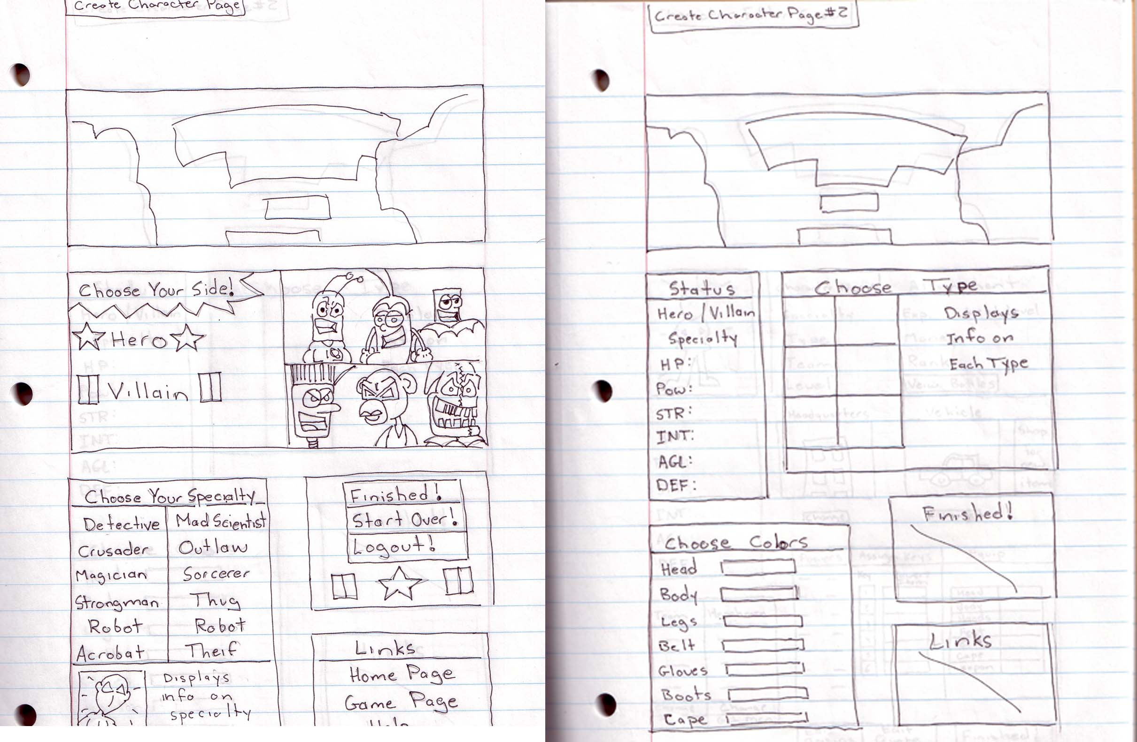

Next up is the character editor. Aside from a few windows, most of the webpage will consist of flash animations. However, the character editor needs to be flash independent, because I don’t know how to do forms yet.
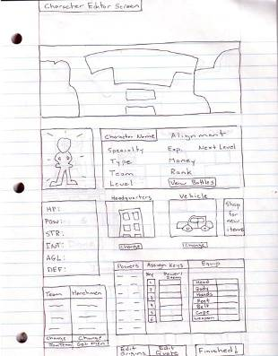
Alright. So on the character editor, all the information on a character will be displayed. Some things will also be editable. From here you will be able to check out your inventory, assign henchmen, teams, headquarters, and vehicles. If you look where it says assign keys, instead it will show your inventory. You will also have the option of adding a quote and an origin story. From this page you will be able to shop for new items and learn new powers.
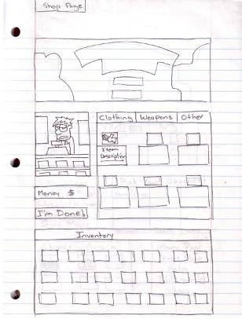
The store will of course allow you to buy and sell items. It will have to be separate from the game as well. The cashier will be flash animated, however, and he will give continuous comments to you while you shop.
On a side note, the option of integrating the expansion site with the main site allows for interesting possibilities. One of which is the ability to “buy” files from the main site with game money, and also to embed secrets, such as items, into the main site, giving people incentive to check out the rest of the main website. Also, users will need only one login to use all facets of the site.
One of the projects I’d like to see happen is a giant tutorial on how we put the expansion site together. Everything from html to actionscript would be available to those who choose to follow our example. But that’s a little off subject. On to the next topic.

2. The Game
The game will be based on the continuous struggle of good vs. evil… that is Heroes vs. Villains. After the intense character creation process, a user would then begin his struggles against the opposing side. So let’s look at the different groups.

Heroes- Fight for good. There are no regulations here. As long as you fight evil, you are considered a hero.

Villain- Fight against good. Again, there are no regulations here, you just have to fight the good guys.

Specialties- Here is where the true characters are created. There are 6 specialties for each side.
Detective/ Mad Scientist – They rely completely on their wits. As such, they have and can not have any special abilities. However, their high intelligence allows them to master nearly any item. (high INT, low POW, average+1 AGL, average OTHER)
Crusader/Outlaw – They are the slightly above average group. While not excelling in any one area, they are a step above everyone else. (average +1 OTHER)
Magician/Sorcerer – They command large amounts of power, and as a tradeoff have a weakened physique. (high POW, low STR, average+1 INT, average OTHER)
Strongman/Thug – They rely on brute strength to overcome obstacles, but usually have trouble solving quadratic equations, or remembering telephone numbers. Make a good team with Magicians. (high STR, low INT, average+1 HP, average OTHER)
Robot/Evil Robot – Metal bodies often leave robots unscathed in battle. However, heavy slow-moving metal parts also tend to make them easy to hit.
(high DEF, low AGL, average+1 HP, average OTHER)
Acrobat/Thief – Able to leap around and breakdance like nobody’s business, they tend to have small wiry frames that, while able to dodge large objects, are easily broken like twigs and squirrels. (high AGL, low DEF, average+1 STR, average OTHER)

Okay, so now each specialty will have a stock of different appearances. Right now, I have come up with about 6 different looks for each specialty… 4 male and 2 female. I would like the user to be able to customize each character, but I’m afraid it might be a little to much work, so maybe I’ll settle for a customizable symbol or crest.

Next up is the attributes. There are only 6 attributes, so that our lives may be easier. They are as follows:
HP – hit points
POW- power (for special abilities)
STR- strength
INT- intelligence
AGL – agility
DEF – defense

Each attribute has a defensive or offensive purpose. For HP, DEF, and AGL, these are used to calculate what effect an attack has on a character. AGL determines whether a character is hit, DEF determines how much damages the character takes, and HP is how many hits a character can take until he is defeated (characters cannot “die” technically, they merely lose the battle.) POW, STR, and INT determine the damage given. INT determines if the character can use a certain item. POW effects special abilities. When POW is depleted, special abilities are no longer available. STR of course is the amount of damage a physical attack does on an opponent.

Okay, I know all this stuff is pretty redundant, but, I just wanted to point out the simplicity of this system. Of course, there would also have to be other things thrown in (such as when a character attacks, he does between 6 and 10 damage, and an opponents defense would be based on similar scales.)

So, now we get into system modifiers. This states that there are minimum and maximum damage/defense scores. A simple equation should take care of this, something that says that 30% of the time you hit minimum, 40% you hit for something in between min and max, and 30% of the time you hit for max. I’m sure we could add something in there for Criticals as well, if we wanted to be all cliché and shit.

Now that we’ve gotten into attributes, let’s talk about items. All items do is effect attributes, except projectiles, which deliver damage. Some items require prerequisites to use them, others run out after a certain amount of time, and still others effect the attributes of either the player or the opponent.
A good example of a weapon is a simple handgun. Let’s say it requires an INT of 3 to use it, and it has a damage range from 2-6. It won’t matter how high your character’s INT is, as long as it is higher than 3. When used, it will only do a maximum of 6 damage. On the other hand, a melee weapon, like a baseball bat, requires a STR of 1 to use. It will then add +1 to STR when used. So, if a character has 10 STR and uses a baseball bat, he will be hitting for a max of 11 damage. It is the same with powers. Projectile powers, such as lightning bolts, have a max damage independent from other attributes, but they use up POW. Melee powers, such as Fists of Asparagus, add modifiers to STR, and also use up POW.

Items which are not clothing are considered clothing. All these items do is effect attributes. For instance, the Ankle Bracelets of the Rhinoceros give a +3 to STR, but are considered clothing because they cannot be used as a weapon. Powers that cannot be used as weapons are considered Enchantments. The Lonely Ballad of the Degraded Mongooses gives the singer +1 to AGL, but it cannot be used to damage the opponent. Powers that effect the opponent but don’t do damage are also considered Enchantments.
However, powers and items can do more than effect attributes.

The items and powers that don’t effect attributes or do damage are considered special. Special items include objects like the Smothering Thumb of Saint Crinkulustus, which when used, would prevent an opponent from performing any actions for three turns. Also, special powers include the power of Invisibility, which would prevent an opponent from being able to attack you.

All of the previous subjects are loaded into the game from the website. The game itself will begin by loading all of these variables, and then showing a main screen with all of that info, plus a couple of options. The player must first equip himself in the main game screen. He will then be presented with the options of battling other players or going solo. If he chooses to battle other players, he will go to a webpage with a list of everyone on the opposing side. He will then be able to choose an opponent and fight him. If he chooses to Story Mode, he will be presented with a map of the city. Different areas of the city will be selectable. Some are doorways to “dungeons” that contain random battles. Here is the kicker. Random battles will consist of both stock enemies AND other players’ characters. So, not only will you fight hordes of purse snatchers, but you will also have to battle an opponent who is a level higher than you just as often.
I’m still not sure how I’m going to do the AI for NPCs (which, even if they are another player’s character, they are considered NPCs in combat.) I was thinking of something along the lines of attacking constantly, with random powers or weapons. If we do this, we might have to make users equip weapons before they start the game.

In addition to regular combat, you will be given various goals to accomplish, in order to receive necessary items or powers. In fact, I might make it so that the only way to learn new powers is through the Story Mode. Anyway, so you go on these missions, and each one will be loaded into the main game flash from a separate flash file. That way, I can post up missions in a central area in town and people can except them depending on their experience.

Okay, so that’s the extent I’ve thought about the solo play. Now, as far as fighting other users, there are 3 modes of play. Player vs. Player, which is one opponent fighting another. Sidekicks vs. Henchmen, which is a Hero and Sidekicks vs. a Villain and his Henchmen. Sidekicks/henchmen are either purchased or acquired through Story Mode.Then there would also be Team Combat! During the course of the game, alliances will be forged and broken, and groups of Heroes may want to go after groups of Villains, and vice versa. So, we will have TEAM COMBAT. The user will join an alliance, or team, and then pick as much as three other team members to combat a team of Villains. Each player will have the option on his Character Editor to join a team and pick team members to fight along side him.

In addition to all of this, there are the vehicles and headquarters. Vehicles allow you to get to certain places unavailable on foot. A car would allow you to reach the county side. A rocket would let you reach the moon. Headquarters are where you store all of your items. The larger the headquarters, the more shit and henchmen you can have. Also, your headquarters location determines if others can reach you or not. While anyone can get to your house in the suburbs, not everyone will be able to reach your Moon Base! Or, only those with a high agility will be able to get past your security. This would mean that you aren’t constantly bombarded by attacks, but instead can pick what kind of players are able to attack you.

When a player’s headquarters are breached and they are defeated, they lose a certain amount of money. If they a re Heroes, it was stolen by Villains. If it was a Villain, the money is assumed to be stolen and is returned to the bank, with a reward given to the Hero. Either way, a player loses money when defeated, regardless.

I was also thinking of adding a secret identity simulator. It would be something like, you have work at your job after so many battles, or you only have so many turns available before you have to return to your job. Then, you would have to do stupid tasks while in Story Mode in order to get a raise. I dunno.

Well, that’s about all I have for the game. I guess its on to the next subject

3. The Animation

Okay, this is the good stuff. I already have the scripts written for Flash animations that will keep me busy for the rest of my life. At least, that’s what I thought. Then I figured out something that will cut production time by half. Without going into too many details, I am able to now control movie clips through actionscript. So, if a character says “I hate turtles” I simply have to type in mouth=”I” and so on and it will play that character’s mouth movements for the sound of “I”. This can also be used in a variety of different ways, but you see what I’m getting at. Anyway, the animations will be released as they are finished. I am hoping I can find some people willing to do voices.

So, the animations will of course tie in with the game. The first set of movies have to do with an alien invasion, much like a comical version of War of the Worlds, but with superheroes. I will send you the scripts themselves, and if you get a chance to read them and add suggestions, then cool. I wrote them all in the course of about two weeks, so they might be a little rough. Anyway, the main characters will effect everything from the game to the main website. However, they will not be All-Powerful beings. I’d like to keep them on the players’ level, almost as if they are controlled by users. In addition to the main storyline animations, I will also animate other characters as well, such as the anchorman and the convenience store clerk. I will also add various other characters throughout the game and website. Any input on this would be much obliged. Another area for concern is the music. I’ve come up with a lot, but I need more and different. I keep getting stuck, so if you are still playing drums and guitar, send me anything you think I can use.

In conclusion:
Well, there’s the website, the game, and the animation in a nutshell. I think it would be a good idea to get organized now. Its not something I think that either one of us is good at, but a start would be an area of the website to put up our ideas, away from the eyes of the normal user. An admin only area where we, and anyone we allow in the future, are able to post up our ideas and requests. Let me know what you think about all of this. I know that a lot of the stuff in here seems incomplete, but that’s just because it is. Oh and remember:
“Idle hands are the tool of the devil. Idle threats are the tool of a coward. Idle thoughts are the tool of an imbecile.” – Defective Will

